Remote Work Policy
COVID-19 Social Distancing & Exposure Management (as of 3/22/20)

[INSERT COMPANY NAME HERE] prides itself on a dynamic and flexible work environment. Remote work is a discretionary privilege that may be extended to some employees for mutual benefit. If this privilege is used purposefully and our clients/members/team members are served well, we will continue this practice.

Further, [INSERT COMPANY NAME HERE] wants to provide a safe work environment and ensure that it is taking every precaution to protect employees from COVID-19 exposure. In addition to personal hygiene and Mass Gatherings Risk Management Practices, we can practice reasonable social distancing best-practices, especially for Vulnerable Populations. As such, effective immediately, all employees may work remotely if they meet any of the following criterion:

1.Are identified as being part of a CDC Defined Vulnerable Population or have a member of the household identified as a member of a CDC defined vulnerable population.
2. Have been exposed to anyone infected with COVID-19.
3. Are identified as having a weakened immune system or have a member of the household identified as having a weakened immune system.

The period of remote work will depend upon each unique circumstance and authorized by your supervisor within HIPAA guidelines.

Remote work may also require designation on your MS Outlook Calendar. Specifically, open your MS Outlook Calendar and select the “New Appointment” button. On this screen, type “Remote Work-COVID-19” in the Subject field and type “Home Office” in the Location field. Also, select “Working Elsewhere” in the Show As field’s dropdown menu (see below).

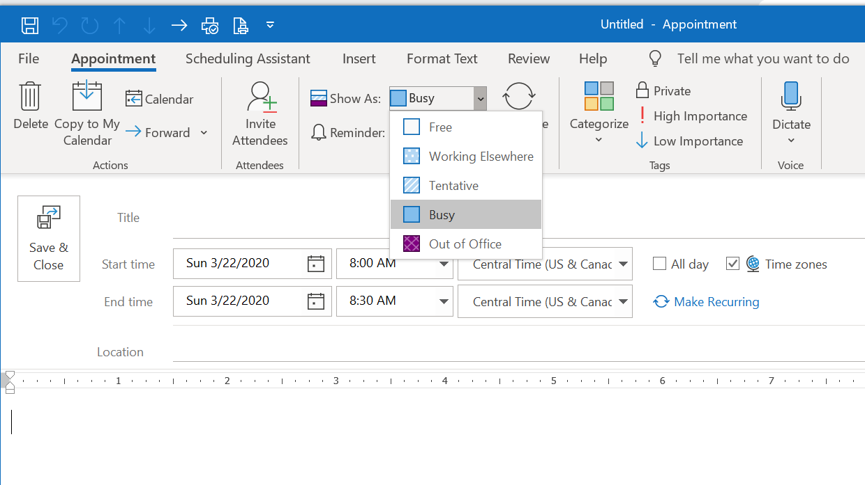

Disclaimer: The information provided herein does not, and is not intended to, constitute legal
advice; instead, all information, content, and materials provided are for general informational
purposes only and suggested guidance based on the best available information at the time. This should be reviewed by your own legal counsel.

